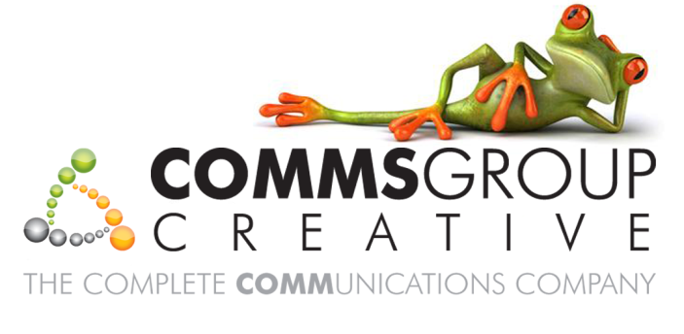

**Comms Business Solution**

For

**QD Stores Group**

Date:-05/12/2011

Prepared by:-Wayde Rathbone

Contact:-Justin Farrington-Smith

Based on the information supplied in by QD Stores Group e-commerce platform request proposal, -and our subsequent meeting for higher level requirement analysis, we have put together this documentation as a “starter guide”, but anticipate that the project will involve further investigation to be able to fully provide a detailed low level specification document and fixed prices.

**The Project:-**

**Currently:** The group currently has e-commerce sites, but is looking for a fully integrated solution for its wide product range of around 30,000 products. The integrated solution should be compatible with SAP and Winretail POS Management System that the company is currently using. It is essential for us to fully understand the software and Business processes that the company has in place to be able to provide a detailed quotation.

**We understood that: T**he Group is looking for a content managed e-commerce solution, which will be integrated with a payment service provider. The system will also have sale order processing, sale order tracking and a mobile interface.

Comms Group Creative is Sagepay e-commerce partners and would highly recommend using Sagepay as the preferred payment services provider.

At Comms Group Creative we have developed our own unique CBS Business Solution which is designed in ASP.NET, the system runs over Microsoft Sequel Server database and is both scalable and robust. Full training and user guide documentation will be provided on the CMS. The CMS platform is built with internal Search Engine Optimisation features for adding page titles, descriptions and tags, and follow best practice SEO techniques. And currently being used by many companies successfully,

**Our Team:** Our team members have experience in developing systems that are currently handling around 20,000 products, and a long experience of developing ecommerce systems along with integration with the existing systems.

Along with the build and delivery of the e-commerce website, the Group is looking for marketing support in terms of Social Media, Blogging, PR, Article Writing, Link Building, Affiliate Marketing, Pay Per Click, Link Building & e-Mail Marketing Services. Comms Group Creative will be more than happy to assist in all the above areas based on the group’s requirements and budgets.

In order to create a good e-commerce website, certain elements of the website need to be addressed as priority, these are:-

* **Graphic Design** – It is a known fact that websites that are professionally designed have a higher conversion rate. Sites generally have 3-5 seconds to convince the user that the site is professional and will offer a good surfing / shopping experience. Much of the design element of the website will be coming up with the “look and feel” of the site to ensure a good user experience.
* **Content** – Content is vital to any website. With regards to e-commerce websites it is important to have good quality imagery and product descriptions. All too often when data imports are carried out (from other applications) the content is not detailed and poor quality. It is essential that the content provided is good quality.
* **Functional** – With any e-commerce website the process of adding the product to the basket and checkout should be as seamless as possible. Where you have a lot of repeat orders, a token system may be applied to these clients whereby Sagepay hold the clients card information and the clients may have a click and buy process.
* **Update Strategy** – With any good e-commerce website, the strategy should be to offer clients the latest products and prices. The ability to keep the site updated will involve data imports and image uploads and will require ongoing maintenance and work. This may be done in-house or under a maintenance contract.

**Services:-**

Comms Group Creative is an on and off-line creative design agency providing graphic design and website design services for SME’s through to PLC’s. Comms Group Creative is part of the Comms Group (UK) Ltd. who provide telephone systems, support and networking services. Please see additional services for more information.

All websites will be created using a concept design service, whereby we will design and provide access to a visual which will be agreed. Once the “look and feel” of the website has been agreed, we will commence with the coding of the project. Typically, the theme of the “look and feel” of the agreed concept will follow through on the rest of the website pages.

If third party software is used, there may be an additional cost for the use of this third party software / licensing unless agreed previously.

We often utilise stock images from different stock libraries. The cost of the site will include the cost of low resolution stock photography based on a “reasonable amount” of images. Should you require additional imagery, this again may incur additional cost.

Comms Group Creative offer hosting e-mail and domain name registration services. We are able to provide hosting and support services as required.

**Marketing Services:-**

Comms Group Creative provide a full design and marketing service including:-

* Design
* Branding / Rebranding
* Illustrations
* Print (brochures / catalogues etc)
* Corporate Stationary
* Marketing Literature
* Exhibition Branding
* Web Design / e-commerce & CMS
* Marketing
* Search Engine Optimisation
* Pay per Click Marketing Campaigns
* Social Media Marketing
* PR
* E-Mail Marketing
* Ongoing site promotion / monitoring

**Specification:-**

Development of bespoke functionality will be discussed and agreed in a final specification document. Please note that if elements of functionality are not agreed prior to commencement of the coding there may be additional costs involved.

**Ownership Rights:-**

Ownership and materials of the website will belong to your company provided the site has been paid for in full. As you are trading as a Limited Company, your company registration details need to be available on the website. If you are collecting customer data, you need to have a privacy statement as per the data protection act and provide an “opt” out service. It is also advised to clearly state your terms and conditions of business on your website. Comms Group Creative are not responsible for the content of your website, so please ensure any stock images or copy provided are your copyright and or have been paid for in full.

**Mutual Confidentiality:-**

Customer and Company acknowledge and agree that the specification and all other documents related to the performance, production and creation of the website remains the property of the customer. Should a non-disclosure agreement be necessary, please advise.

**Payment Terms:-**

Our standard payment terms are 50% on commencement of project and balance on completion. Should you require different payment terms please advise us and these will be agreed prior to commencement of the project.

**Site Map:-**

As the site is content managed, producing a site map is not possible, however it is anticipated that the site will follow a logical site structure with the ability for clients to search and easily locate products that they are looking for.

**System Integration:-**

The SAP / Winretail software integration will require further investigation as to the processes you are currently running, however some initial questions that we have are:-

* Instock vendor feeds:- how would this data be supplied and how are you anticipating pricing these products.
* Stocked to order items:- Is the order to the vendor automated or will this be processed manually in-house?.
* Customer Returns – How are you anticipating the customer returns processes to work?
* What versions of SAP & Win retail are you currently operating?

**CMS user guide**

See Appendix 1.

**CMS SAP Integration process**

Ass Appendix 2.

Once a detailed specification document has been agreed and the scope of the project has been agreed in principal, we will be able to provide you with a fixed cost for the project and development processes.